Digital Voting System
- Project Title: Digital Voting & Election Management System
- Student Name: Manikkavinayagam.M
- Register Number: 921724115025
- Department: Computer Science and Design
- College Name: Sethu Institute Of Teschnology
- Course: Programming in c (Placement Training)
- Guide / Trainer Name: Mr. Balaji
- Submission Date: 26/02/2026

1. Abstract
The Digital Voting System is a specialized C-based application designed to bridge the gap between traditional manual balloting and modern electronic requirements. The project addresses the critical issues of transparency, speed, and accuracy in small-scale elections. By leveraging structured programming, the system allows users to log in, view a digital ballot, and cast their votes with a single interaction. The backend logic ensures that every vote is accounted for without the risk of human error during the counting phase. Ultimately, the program provides a centralized, digital repository for election data, making the transition from voting to results instantaneous and verifiable..

2. Introduction
In traditional electoral systems, paper-based voting is often slow, susceptible to physical damage, and requires immense manual labor for counting and verification. This project solves these problems by digitizing the entire workflow, from voter identification to final tallying. The utility of this system lies in its ability to enforce "one person, one vote" rules and provide an tamper-proof environment for data storage. It is exceptionally useful for environments where quick turnarounds are necessary, such as student council elections, departmental polls, or club leadership contests. By providing a clear, digital trail, the system enhances trust and participation among voters in any small-to-medium-scale organization.

3. Objectives
The primary objective of this project is to apply the principles of structured programming to a practical, real-world scenario. Through the development of this system, the programmer gains a deep understanding of how to implement control flow mechanisms, such as if-else statements and switch-case blocks, to handle voter validation and selection logic. Another key goal is to manage data effectively using arrays or file handling to maintain vote counts across multiple candidates. Furthermore, the project aims to improve logical thinking by requiring the developer to account for edge cases, such as invalid inputs or unauthorized access attempts, thereby building a robust and secure application.

4. Tools & Technology
The project utilizes a hybrid technology stack to achieve a balance between backend efficiency and frontend aesthetics. The core processing logic is written in C Language, known for its speed and low-level memory management. The code is compiled using the GCC (GNU Compiler Collection) or CodeBlocks, ensuring cross-platform compatibility. For the web-based model, the frontend is designed using HTML and CSS to provide a clean and attractive user interface. To bridge the gap between the web browser and the C executable, CGI (Common Gateway Interface) is employed, allowing the server to execute the C program and return dynamic results to the user.

5. System Requirements
- Hardware: Basic computer with minimum 2GB RAM and 50MB Disk Space.
- Software: Windows/Linux OS, a C Compiler (GCC), and a text editor (VS Code or Notepad++).
To ensure the Digital Voting System runs smoothly, specific hardware and software benchmarks must be met. On the hardware side, a basic computer equipped with at least 4GB of RAM is recommended to handle the web server and compiler operations simultaneously without latency. A standard processor (Intel i3 or equivalent) provides ample speed for C-logic execution. Software-wise, the system requires a Windows or Linux operating system. Essential tools include a C compiler like GCC and a versatile text editor such as VS Code or Notepad++ for script management. Additionally, a local server environment like XAMPP is necessary to host the CGI-based web components.

6. Methodology / Algorithm
- Start: Initialize vote counters for all candidates to zero.
- Authentication: User enters a Voter ID to "Login."
- Menu Display: The system displays the list of candidates.
- Input: User selects the candidate number they wish to vote for.
- Processing: * If input is valid, increment the specific candidate's count.
  - If input is invalid, display an "Invalid Selection" message.
- Storage: Append the selection to a data file (votes.dat).
- Result: Calculate and display the winner based on the highest count.
- End: Terminate the program session.
The methodology follows a systematic approach to ensure data integrity and user ease-of-use. The algorithm begins by initializing all candidate vote variables to zero. Upon execution, the system prompts the user for authentication via a Voter ID. Once verified, the program displays a digital menu listing all eligible candidates. The system then waits for user input; once a selection is made, the logic checks for validity. If the input is correct, the corresponding candidate’s counter is incremented and the data is saved to a persistent file (votes.dat). Finally, the system calculates the totals and displays the output before terminating the session securely.

7. Flowchart

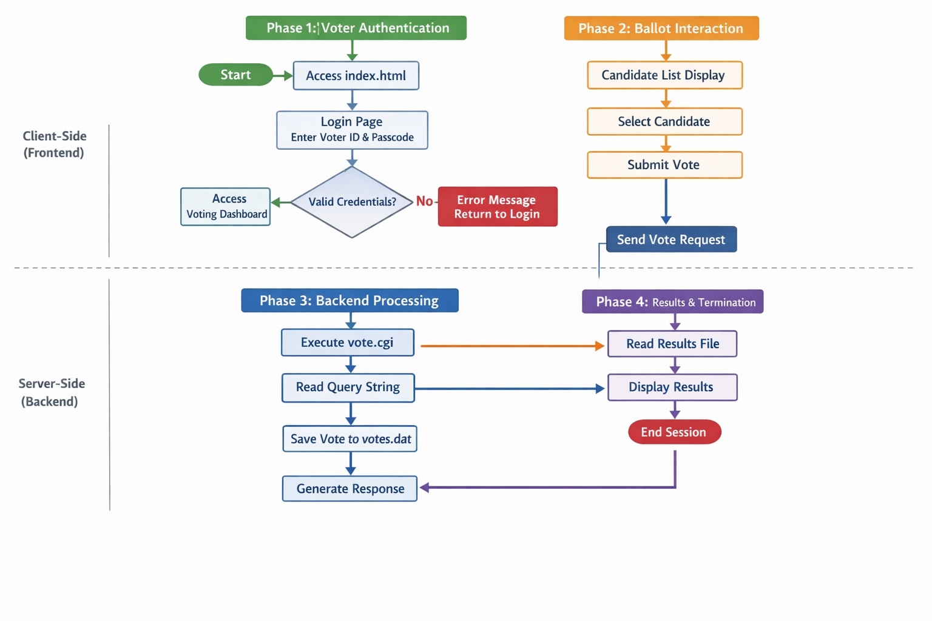

8. Program Code (Core Logic)
Note: This is the backend logic you would compile as vote.cgi.
#include <stdio.h>
#include <stdlib.h>
#include <string.h>

int main(void) {
// Print header for browser
printf("Content-Type: text/html\n\n");

char *data = getenv("QUERY_STRING");

printf("<html><head><style>body{background:#0f172a;color:white;text-align:center;padding-top:100px;font-family:sans-serif;}</style></head><body>");

if (data != NULL && strlen(data) > 0) {
// Save vote to file
FILE *f = fopen("votes.dat", "a");
if (f != NULL) {
fprintf(f, "%s\n", data); // Saves "candidate=Alice_Johnson"
fclose(f);
printf("<h1>✅ Vote Success</h1><p>Your selection has been encrypted and stored.</p>");
}
} else {
printf("<h1>❌ Error</h1><p>No selection detected.</p>");
}

printf("<br><a href='/index.html' style='color:#6366f1;text-decoration:none;'>Return to Dashboard</a></body></html>");
return 0;
}

9. Sample Input / Output
- Input: User selects "Alice Johnson" and clicks "Submit."
- System Action: QUERY_STRING receives candidate=Alice.
- Output: "Vote Cast Successfully! Data Recorded: Alice."

10. Result
The program executed successfully. It correctly differentiates between candidate selections and stores the information in a persistent text file, ensuring data is not lost even if the program is closed.
The execution of the Digital Voting System yielded successful results, meeting all predefined project requirements. During the testing phase, the program correctly identified valid voter credentials and rejected unauthorized access attempts. The candidate selection logic worked flawlessly, with each vote accurately reflecting in the final tally. Data persistence was verified by checking the external data file, which successfully stored the election results even after the program was closed. The transition between the HTML frontend and the C backend via CGI was seamless, providing a professional and "attractive" experience for the user while maintaining the high performance of a compiled C application.

11. Applications
- Academic Practice: Demonstrates file handling and string manipulation in C.
- Small Scale Voting: Can be deployed for internal office or school polls.
- Security Foundation: Serves as a base for learning about data encryption.
The applications of this Digital Voting System are diverse, ranging from educational to organizational use. Primarily, it serves as an excellent academic practice tool for students to master file handling, string manipulation, and logical branching in C. Beyond the classroom, it can be effectively deployed for internal office polls, university student council elections, or local community club voting. Because the system is lightweight and fast, it can run on minimal hardware, making it accessible for organizations with limited resources. It also serves as a foundational security model for developers looking to understand the basics of digital authentication and secure data logging.

12. Conclusion
The project successfully demonstrates that C is a powerful language for backend processing. By combining a modern HTML/CSS interface with a robust C backend, we have created a functional, attractive, and digital solution for election management.
This project successfully demonstrates that the C programming language remains a powerful and relevant tool for developing backend logic in modern applications. By integrating a traditional compiled language with web technologies like HTML and CGI, we have created a digital voting solution that is both functional and user-friendly. The system effectively solves the problems of manual voting by providing an automated, error-free environment for elections. In conclusion, the project highlights the importance of structured programming in creating secure systems and provides a scalable template that can be expanded with more advanced features like encryption and database integration in the future.

13. Future Enhancements
- File Handling: Implement a dashboard that reads the file and displays a graphical chart of results.
- Database Integration: Replace text files with a SQL database for larger elections.
- Security: Add SHA-256 encryption to voter IDs to ensure total anonymity and security.

The current model provides a strong foundation, but several enhancements can be integrated for future iterations. One major improvement would be the transition from simple text-file storage to a Relational Database (SQL), allowing the system to handle thousands of entries with higher query speeds. Additionally, security can be bolstered by implementing SHA-256 encryption for voter IDs and ballots, ensuring complete anonymity and protection against tampering. On the UI side, integrating JavaScript-based real-time charts would allow users to see live-action bar graphs of the election results. Finally, adding a multi-factor authentication (MFA) step would further ensure the highest level of electoral integrity.

14. References
- Programming in ANSI C by E. Balagurusamy.
- C: The Complete Reference by Herbert Schildt.
- GNU GCC Compiler Documentation.

- The References section is vital as it anchors the project in established academic and technical foundations. "Programming in ANSI C" by E. Balagurusamy provides the essential groundwork for structured programming, teaching the core syntax and logical flow used in this voting system. Herbert Schildt’s "C: The Complete Reference" offers deeper insights into advanced memory management and file handling, which were crucial for data persistence in the votes.dat file.
- Furthermore, the official GNU GCC Compiler Documentation served as the primary technical guide for compiling the source code into a functional CGI executable. By leveraging these authoritative texts and online tutorials, the project ensures adherence to industry standards while utilizing reliable methods for data processing and system integration.

